DIS-MEX-Chinesco-conjoined twins

Height 6.5 in. Extremely rare.

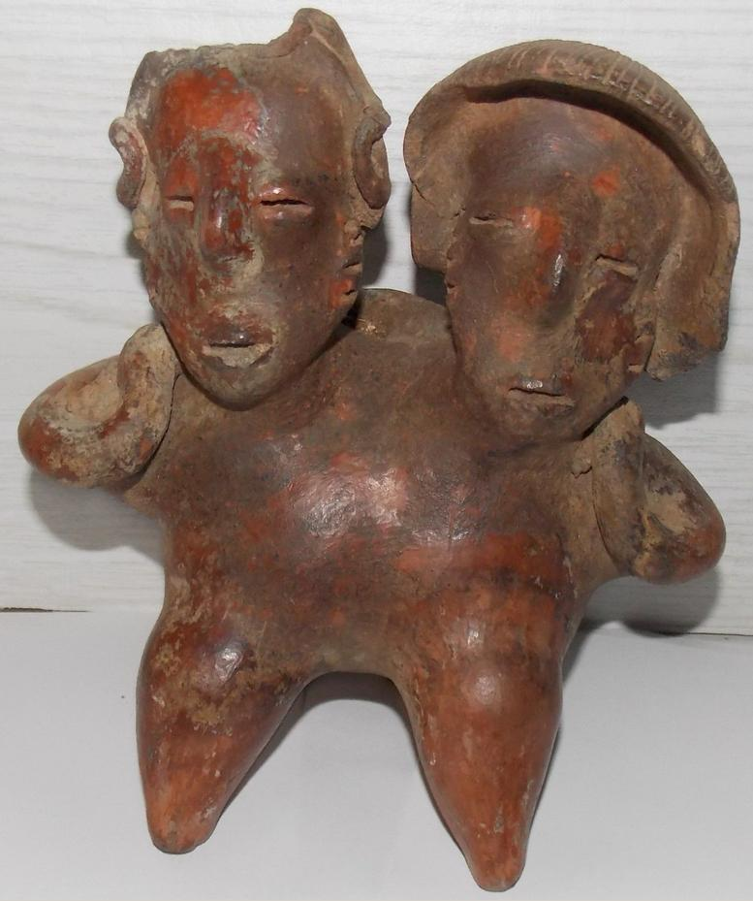 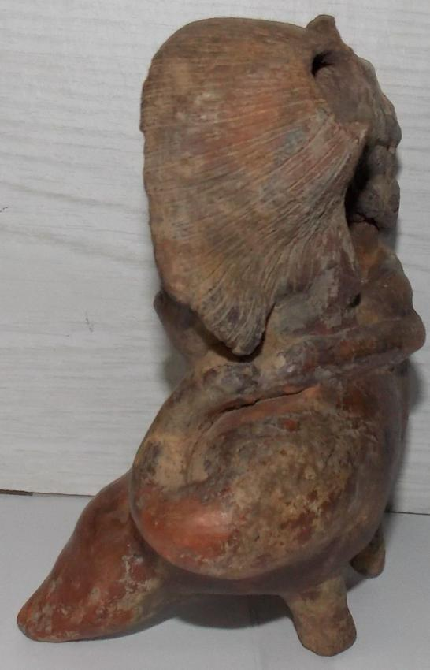 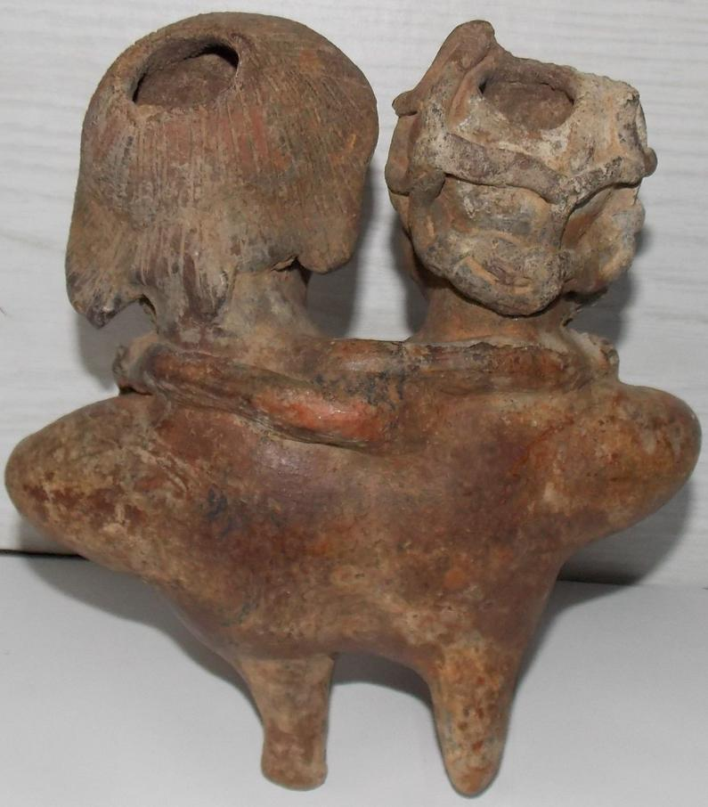 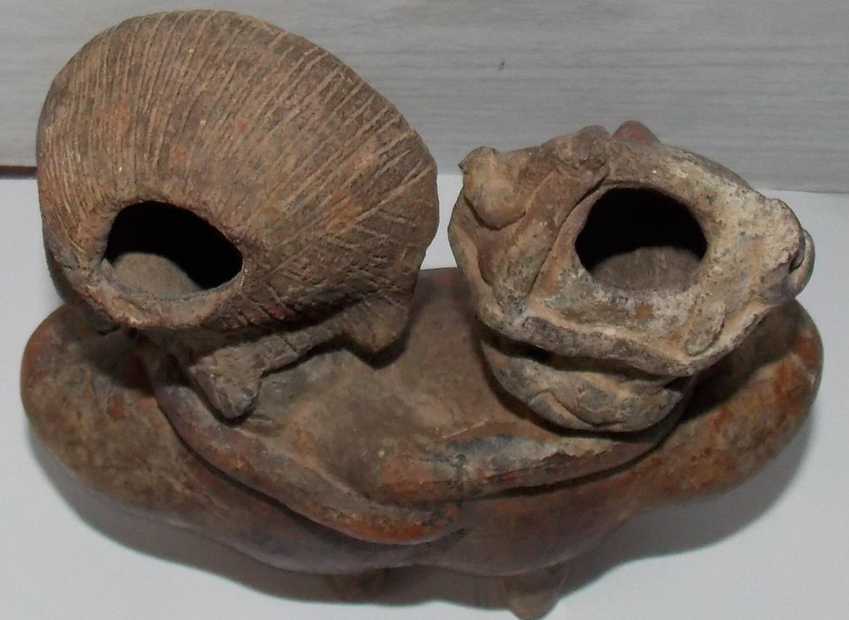 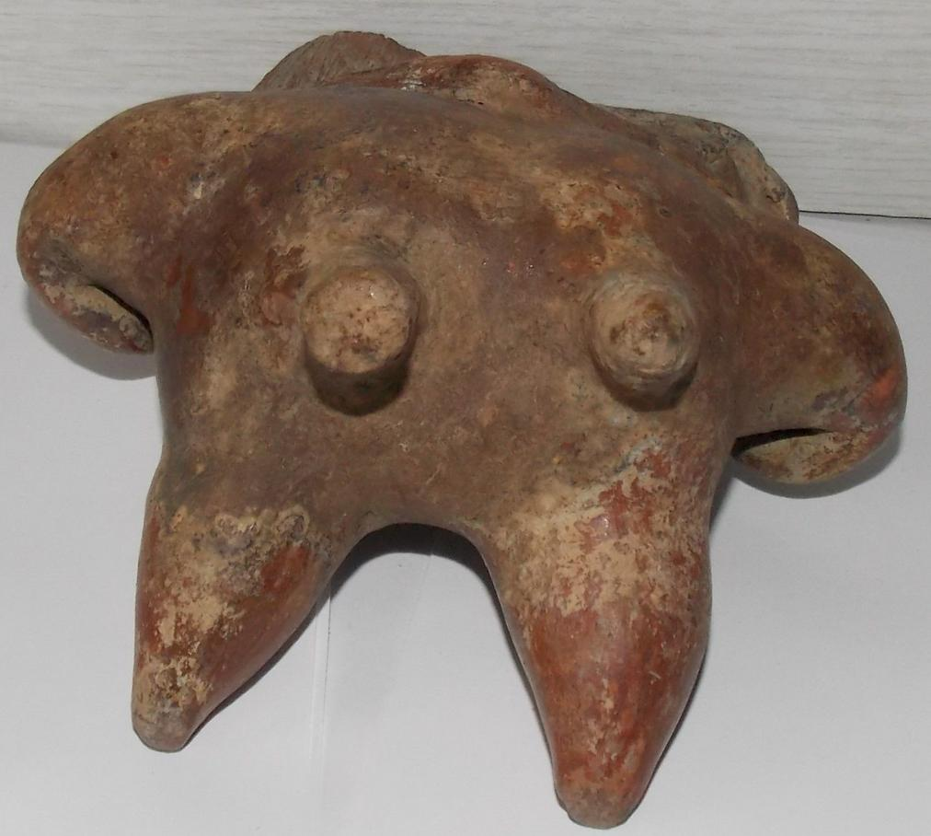

The Western Mexico shaft tomb tradition or shaft tomb culture refers to a set of interlocked cultural traits found in the western Mexican states of Jalisco, Nayarit, and, to a lesser extent, Colima to its south, roughly dating to the period between 300 BCE and 400 CE. Paired sculptures depicting male and female figures frequently occur among the burial goods of the shaft tombs in western Mexico. Built beneath house platforms, these tombs served as family mausoleums and were periodically opened to inter the recently deceased. These two ceramic figures are fine representations of the Nayarit style known as Chinesco, notable for smooth burnished surfaces and painted ornament. These contrast with the heavy three-dimensional costumes and jewelry worn by figures in another local style, the Ixtlán del Río style. This couple¿or "marriage pair," as figures like these have been designated¿may represent ancestors who help to prolong the family line through their guidance and fertility. Fertility imagery often appears in the mortuary offerings of Mesoamerican peoples and is undoubtedly related to concepts of death and the afterlife.

Shaft tomb burials in West Mexico. After <https://upload.wikimedia.org/wikipedia/commons/thumb/d/d3/Ancient_Western_Mexico_Archaeological_Sites.svg/350px-Ancient_Western_Mexico_Archaeological_Sites.svg.png>

References:

Kan, Michael, Clement Meighan, H. B. Nicholson. 1989*. Sculpture of ancient west Mexico: Nayarit, Jalisco, Colima. A catalogue of the Proctor Stafford Collection at the Los Angeles County Museum of Art*. Albuquerque: Los Angeles County Museum of Art in association with University of New Mexico Press.

Sold by [alifeinthepastla...](http://myworld.ebay.com/alifeinthepastlane) ( [26214](http://feedback.ebay.com/ws/eBayISAPI.dll?ViewFeedback&userid=alifeinthepastlane) )

### Delivery package 1 of 1

Estimated delivery Friday, Jan 29, 2016

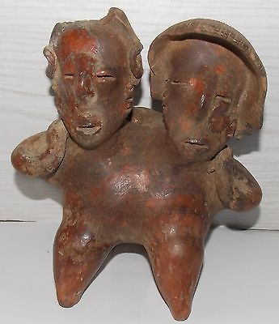

#### [ESTATE PRE-COLUMBIAN POLYCHROME HUGGING COUPLE FIGURES STATUE](http://www.ebay.com/itm/201504222075)

|  |  |
| --- | --- |
| Item price | $659.99 |
| Quantity | 1 |
| Item number | 201504222075 |
| Shipping service | Standard Shipping |

## Sales order

Sold by [tainorocksplus](http://myworld.ebay.com/tainorocksplus) ( [82](http://feedback.ebay.com/ws/eBayISAPI.dll?ViewFeedback&userid=tainorocksplus) )

### Delivery package 1 of 1

Estimated delivery Friday, Jan 29, 2016

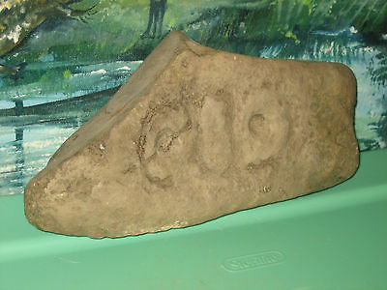

#### [TAINO - DOMINICAN REPUBLIC STONE CARVING ROCK SCULPTURE ARTIFACT FOSSIL # 19](http://www.ebay.com/itm/201491787395)

|  |  |
| --- | --- |
| Item price | $76.00 |
| Quantity | 1 |
| Item number | 201491787395 |
| Shipping service | Standard Shipping |

## Sales order

Sold by [l.orcino](http://myworld.ebay.com/l.orcino) ( [843](http://feedback.ebay.com/ws/eBayISAPI.dll?ViewFeedback&userid=l.orcino) )

### Delivery package 1 of 1

No estimate available

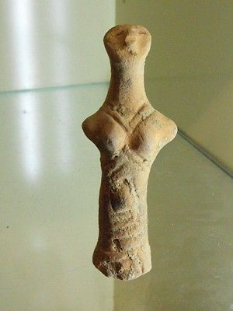

#### [RARE NEOLITHIC CLAY IDOL](http://www.ebay.com/itm/231815194921)

|  |  |
| --- | --- |
| Item price | $177.50 |
| Quantity | 1 |
| Item number | 231815194921 |
| Shipping service | Standard Shipping from outside US |

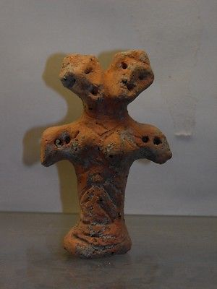

#### [ANCIENT NEOLITHIC CLAY IDOL](http://www.ebay.com/itm/231815202200)

|  |  |
| --- | --- |
| Item price | $222.50 |
| Quantity | 1 |
| Item number | 231815202200 |
| Shipping service | Standard Shipping from outside US |